DIS-AM,S-Peru-Moche-100-700 A,D.

Pre-columbian ceremonial Mask of copper   
Moche Culture a private collection of several years . I will send a certificate of provenance of the vessel   
Moche culture, which developed between 100 and 700 A.D coast North from Peru beginning in the Moche Valley (TRUJILLO - PERU) Measure: 9'' x 10.4 '' inches

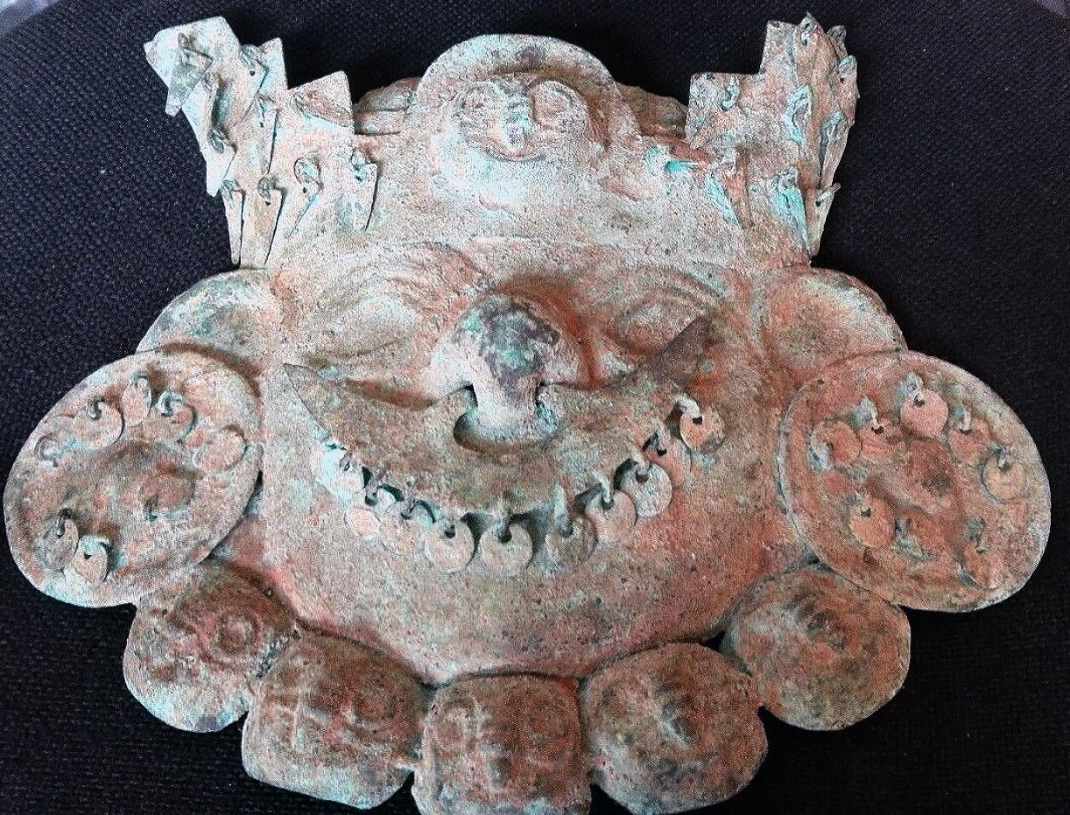

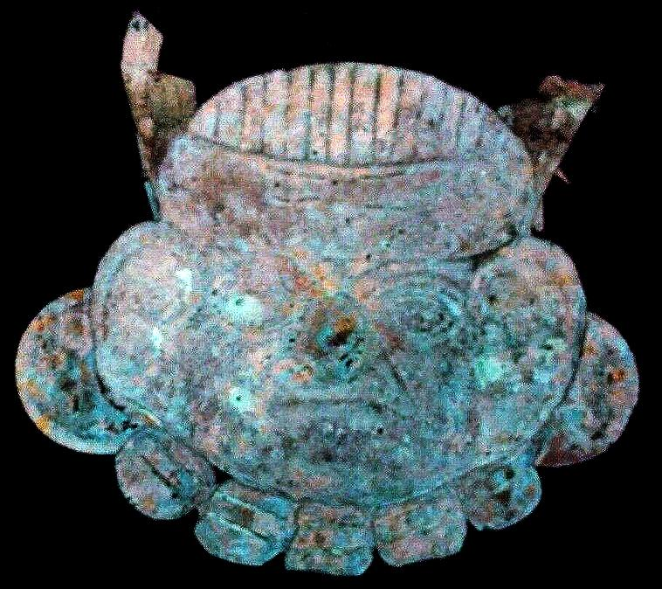

Sold by [mmda.ludisa](http://myworld.ebay.com/mmda.ludisa) ( [10](http://feedback.ebay.com/ws/eBayISAPI.dll?ViewFeedback&userid=mmda.ludisa) )

### Delivery package 1 of 1

No estimate available

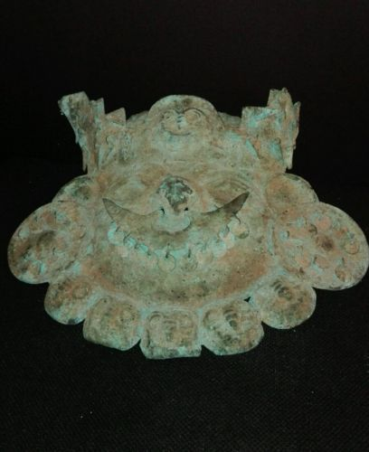

#### [PRE-COLUMBIAN MASK OF COPPER MOCHE](http://www.ebay.com/itm/252309300914)

|  |  |
| --- | --- |
| Item price | $550.00 |
| Quantity | 1 |
| Item number | 252309300914 |
| Shipping service | Standard Shipping |